AdjacentEvaluation() Design Guidelines

Introduction
the Space Engineers Text To Speech Mod is required to match a phoneme for every letter in an english dialogue. To do this there must be rules for which phoneme to choose based on what letter is currently being evaluated.

Problems arise when these rules do not follow a strict design pattern. If not, there can be so many mixed rules that an 'Overwrite' occurs (adding a new word breaks another). The mod's phoneme rules may never reach a complete state if future updates do not follow these guidelines. It must be easy to read and to modify.

Absolute Design Guidelines
- There must be no selection for a silent phoneme.
- There must not be more than one choice for the same phoneme.
- Each choice may have more than one Rule Block.
- Each option must have one of, or both these two components: 'IS', 'IS NOT' as one of it's Rule Blocks.
- Rule blocks can optionally have CONSONANTS.Contains() and/or
VOWELS.Contains().
- An 'IS' component must consist entirely of the use of: "Regex.IsMatch()".
- If an 'IS' component has more than one rule inside it, it must put each rule and its comment on a seperate line.
- An 'IS NOT' component must consist entirely of the use of: "!UnwantedMatch ()".
- Each Component must be on its own line.
- Each Rule Phrase of a Component must have an example word as comment.
- There must be no spaces between comments.
- There must be a space between each Rule Block.
- Each letter case must have an 'else' option.

Example Explained
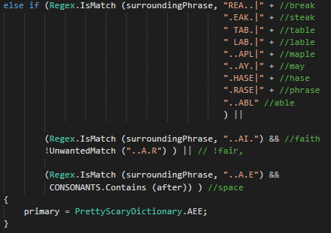
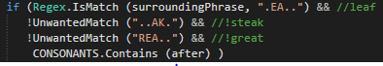
Phoneme Rule Blocks use Regex (Regular Expressions) to check if the characters surrounding the current letter match each Rule Phrase in the Components of a Rule Block. Every current letter is included in the middle of each Rule Phrase to make a search for copies simple and to increase readability.

Regex.IsMatch() is a little too verbose for IS NOT Components so a call should be made to this method of the Pronunciation class. It does the same thing with less text.
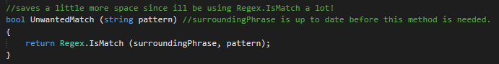
'IS' component
An 'IS' component can check many rule phrases in one but its important that each phrase is seperated by an OR operator.

Example:
Regex.IsMatch (surroundingPhrase, ".EA..|AEAEA") &&

This is because the context of an 'IS' component is its use for matching desireable rule phrases. OR operator works by incrementing once, which makes any other Rule Phrase in this IS Component HIGH. At least one of these must be true in order to be useful.

'IS NOT' component
An 'IS NOT' component is a sequence of bools ANDed together to ensure the current phrase does not match any of these sequences.

Example:
!UnwantedMatch ("..AK.") // !steak, !great

the context of an 'IS NOT' component is its use for matching undesireable rule phrases. Multiplying by zero takes all the other phrases down to LOW. All of these must be false in order to be useful.

Common Problems
- Two instances of the same rule phrase indicates an Overwrite that needs to be fixed.
- If a Rule Block has more than one Rule, it should be in round brackets.
- All UnwantedMatch()'s should have an exclamantion point at the front.
- Every rule must be 5 letters with the current letter in the middle.

